# Background

plotReturnVolatility threw an error:

[1] "Volatility: 15 | 25"

[1] "Returns: -5 | 25"

Error in .prepareFastSubset(isub = isub, x = x, enclos = parent.frame(), : RHS of == is length 57996 which is not 1 or nrow (1000). For robustness, no recycling is allowed (other than of length 1 RHS). Consider %in% instead.

Traceback:

1. plotReturnVolatility(datay.legacy, df.data, df.symbols)

2. geom_line(data = plot_dt[efficient == T], aes(x = sd, y = er),

. size = 0.5, color = "red") # at line 478-530 of file plotHelper.r

3. layer(data = data, mapping = mapping, stat = stat, geom = GeomLine,

. position = position, show.legend = show.legend, inherit.aes = inherit.aes,

. params = list(na.rm = na.rm, orientation = orientation, ...))

4. fortify(data)

5. plot_dt[efficient == T] # at line 478-530 of file plotHelper.r

6. `[.data.table`(plot_dt, efficient == T) # at line 478-530 of file plotHelper.r

7. .prepareFastSubset(isub = isub, x = x, enclos = parent.frame(),

. notjoin = notjoin, verbose = verbose)

8. stop(gettextf("RHS of %s is length %d which is not 1 or nrow (%d). For robustness, no recycling is allowed (other than of length 1 RHS). Consider %%in%% instead.",

. operator, length(RHS), nrow(x), domain = "R-data.table"),

. domain = NA)

In [30]:



string.portfolio.in **<-** datay.legacy

# Solution

Problem seems to be with original code using ‘T’ as appreviate for ‘TRUE’

plot_dt[efficient == T]

Reproduced the error:

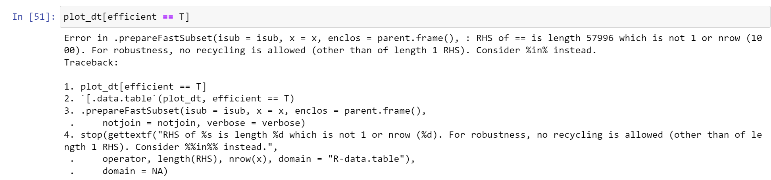

But this:

plot_dt[efficient == TRUE]

Produced good results

